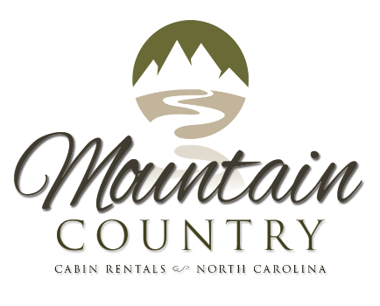 Grocery Shopping

Attached is a copy of our MCCS Grocery Shopping template. Please list all your grocery needs, preferred brands, quantities and any other helpful information so we can shop the best we can for you. We will also provide you with your own personalized shopping list, where you can select what foods/supplies you want. We’ll keep this template on file, should you have any future bookings, you will only need to select from the shopping list.
If you would like us to purchase wine or beer before your arrival, by North Carolina state law we must have the money before purchasing.

Please circle which grocery store you prefer below.
Walmart in Murphy, NC or Ingles Market in Murphy, NC

Do you have any allergies or medical conditions that we should be aware of?

_____________________________________________________________________________________
_____________________________________________________________________________________
_____________________________________________________________________________________
_____________________________________________________________________________________

This will be delivered to your cabin the day before if available or the day of your arrival. We will unpack your groceries and put away before your arrival.
X | Product | Brand | Size | Qty
 | Coffee & Tea
 | Coffee
 | Tea
 | Filters
 | Beverages
 | Orange Juice
 | Apple Juice
 | Soft Drinks
 | Dairy
 | Milk
 | Cheese
 | Yogurt
 | Butter
 | Margarine
 | Ice Cream
 | Bathroom
 | Shampoo
 | Conditioner
 | Body Wash
 | Soap
 | Laundry
 | Washer Detergent
 | Dishwasher Detergent
 | Dryer Sheets
 | Toiletries
 | Paper Towels
 | Toilet Paper
 | Paper plates
 | Napkins
 | Styrofoam cups
 | Plastic Utensils
X | Product | Brand | Size | Qty
 | Meat/Deli
 | Ground Beef
 | Steak
 | Chicken Breast
 | Bacon
 | Sausage
 | Fruit/Vegetables
 | Lettuce
 | Onions
 | Tomatoes
 | Cucumbers
 | Spinach
 | Carrots
 | Grapes
 | Apples
 | Oranges
 | Bananas
 | Breakfast
 | Muffins
 | Cereal
 | Pancake Mix
 | Syrup
 | Eggs
 | Oatmeal
 | Bread
 | Bread
 | Pasta
 | Rice
 | Beer/Wine | Must Provide ID BEFORE Purchase

Please detail the arrangements, including the house address, lockbox code, security access for us to delivery your groceries below if we don’t have access to the cabin already. If you are renting a cabin through Mountain Country Cabin Rentals, please put the cabin you have rented. (Ex. Heaven’s Retreat)
_____________________________________________________________________________________
_____________________________________________________________________________________
_____________________________________________________________________________________
_____________________________________________________________________________________
_____________________________________________________________________________________
_____________________________________________________________________________________
_____________________________________________________________________________________

Is there anything else we need to know?
_____________________________________________________________________________________
_____________________________________________________________________________________
_____________________________________________________________________________________
_____________________________________________________________________________________
____________________________________________________________________________________

Once filled out please fax it or send it to our email so we can make sure we have all your information before your arrival. If you have any questions please don’t hesitate to contact us. We will be happy to help you in anyway we can. Please make note that we do NOT provide alcohol to minors. If requested, we will need to see IDs BEFORE purchase. If renting a cabin from Mountain Country Cabin Rentals, Dish pods and Laundry pods are provided for you to get you started.

I understand I will be charged for any services provided by Mountain Country Concierge Services. By signing, I agree that my card will be charge prior to my arrival. Mountain Country Cabin Rentals & Concierge Services is NOT responsible or liable for anything involving underage drinking.

__________________________________________________
PRINT NAME
__________________________________________________
Sign
_____________
Date

